


111 Snead Dr. • N. Fort Myers, FL 33903
(727) 642-4677
rmapes@mfgsysgroup.com
www.mfgsysgroup.com

Procedure for accessing MSG’s FTP sub-directory

- This procedure assumes you have FTP software installed. We use FTP Explorer. www.ftpx.com
- One time setup for the FTP address - Open the software

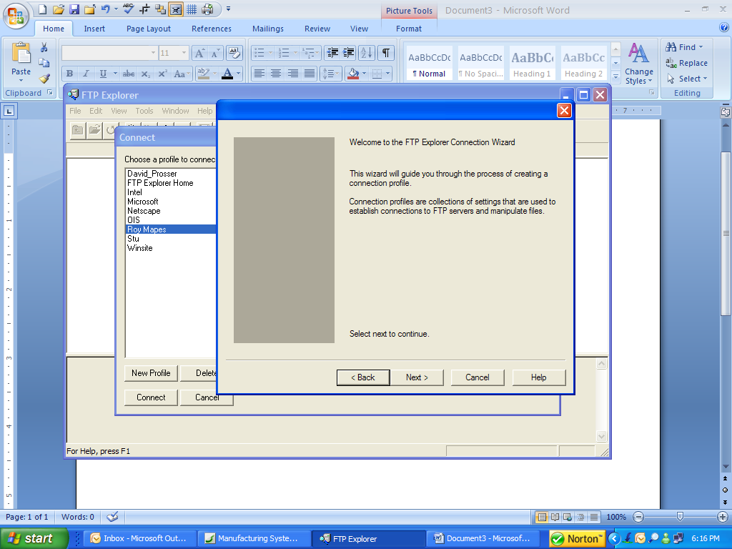
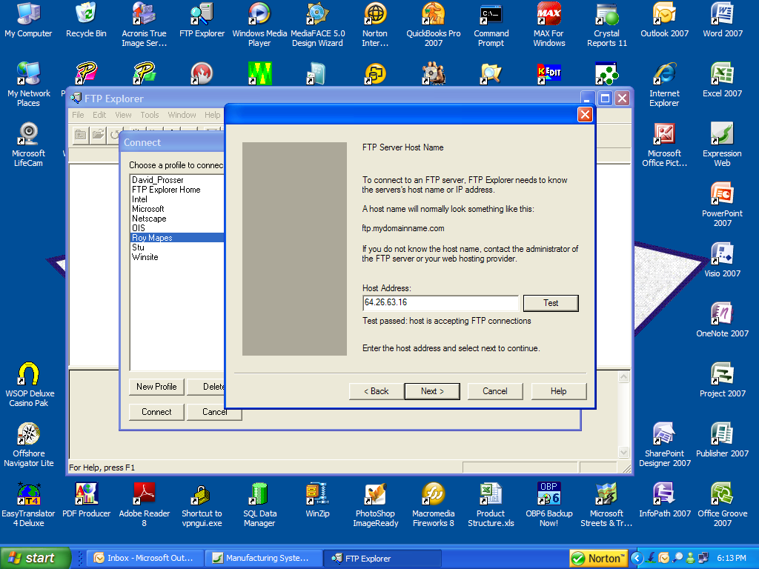

- Click “Next”

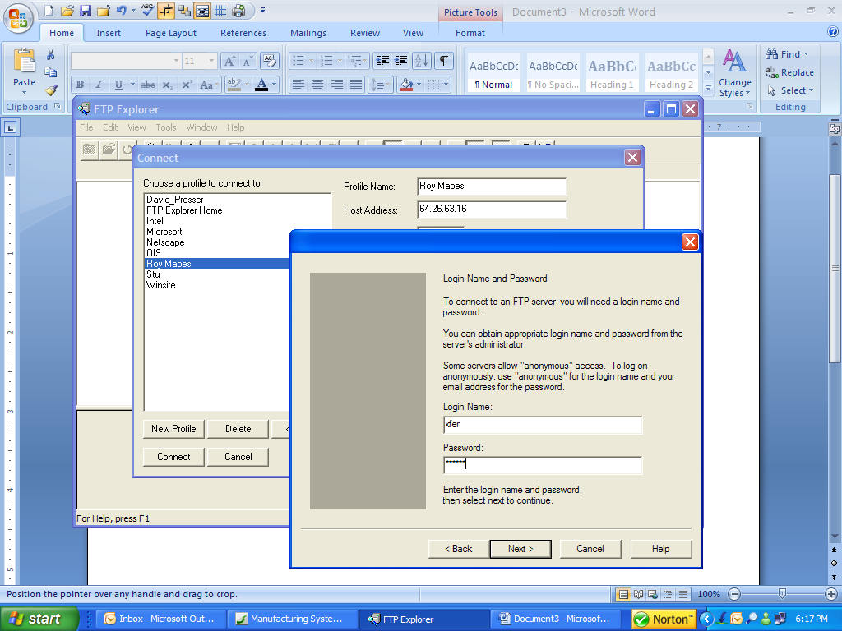
- Enter “Host Address” of: 64.26.63.16

- Enter “Login” name of: xfer

- Enter password : roy0949

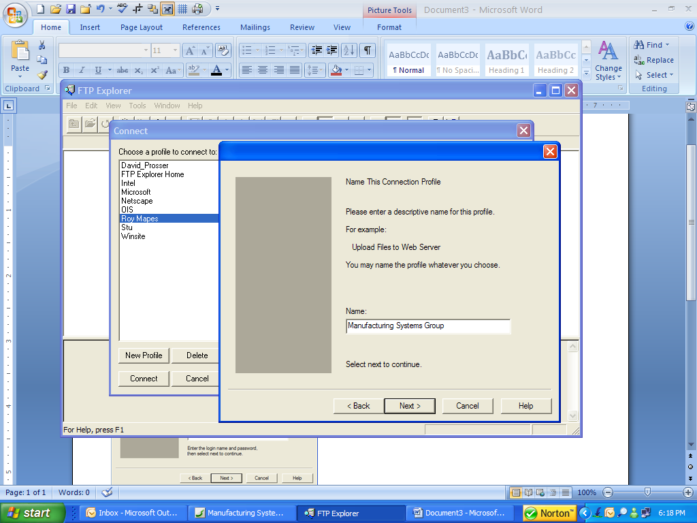

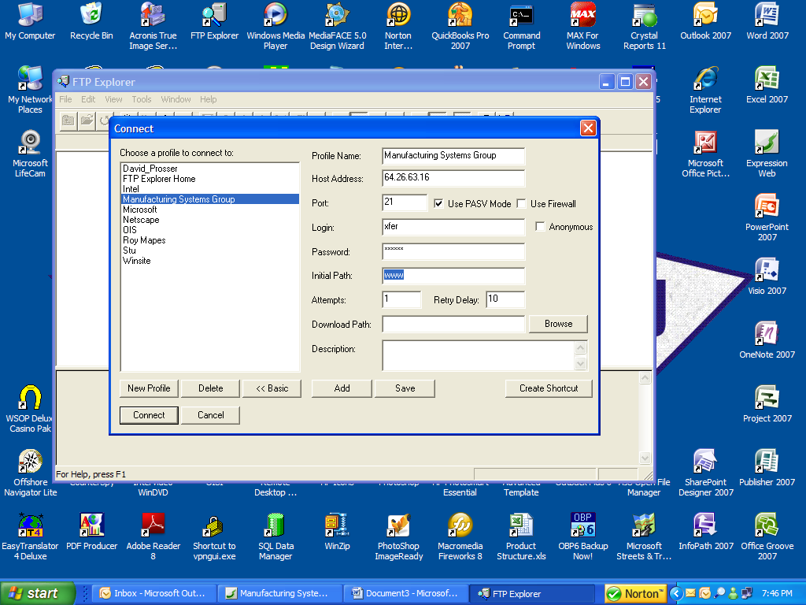

- Enter “Initial Path” of: www

- Click “Save”

Manufacturing Systems Group – Results you can depend on
To upload or download files

- Click “Connect”

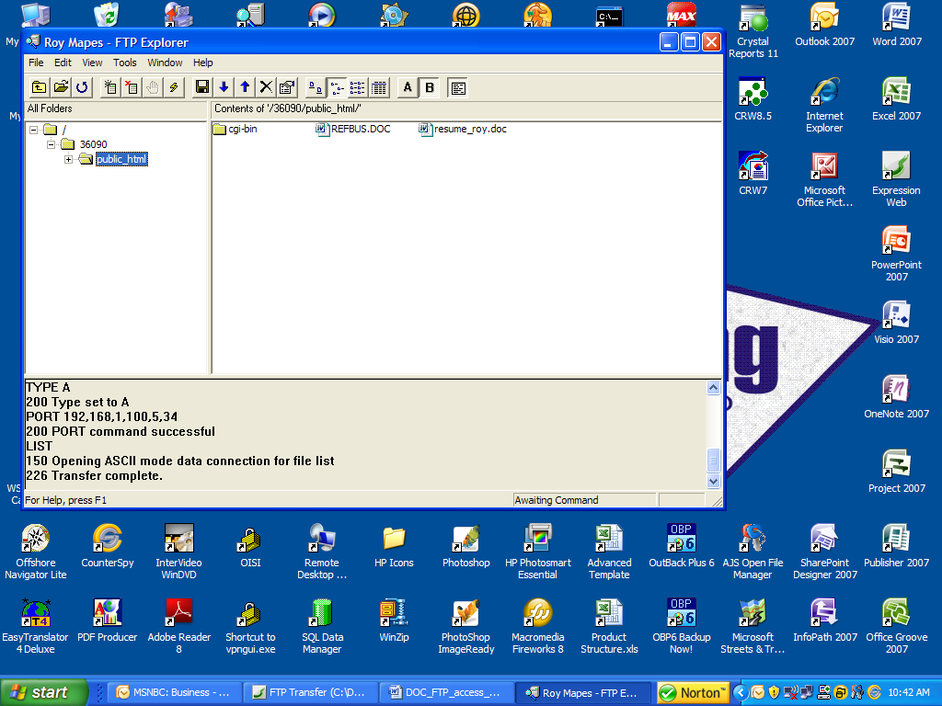
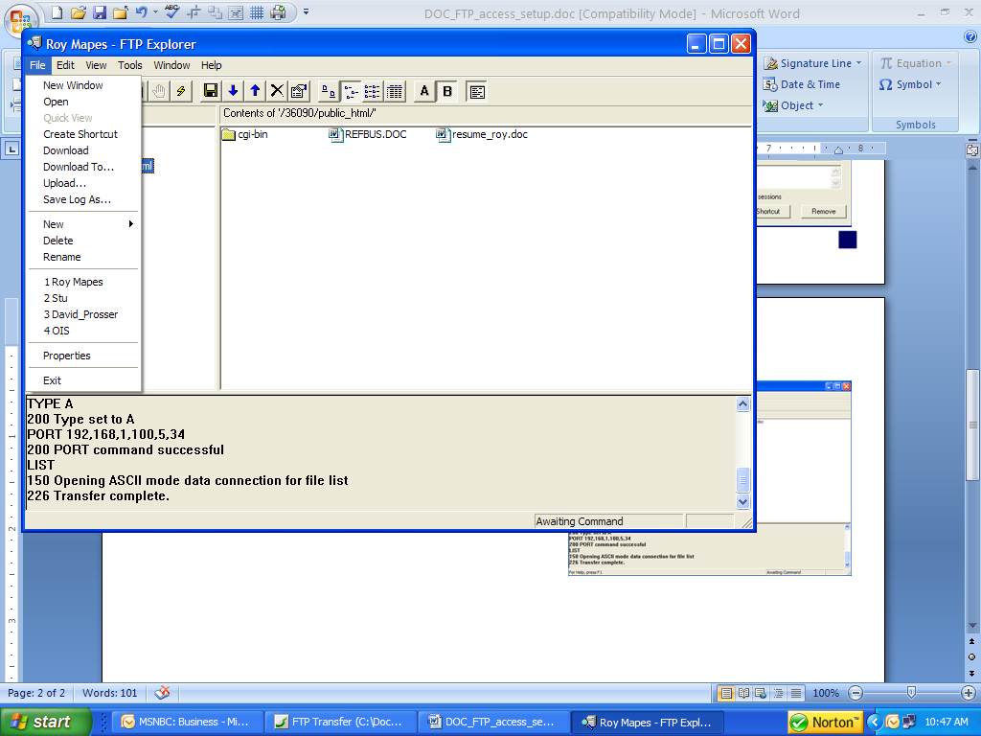
- A window should appear and display available files
- Click “File”. A dropdown window will appear

To Download a file
- Select the file to download
- Click on “Download To”
- System will display the “Download To” window.
- Navigate to the directory to receive the
file then click “Save”

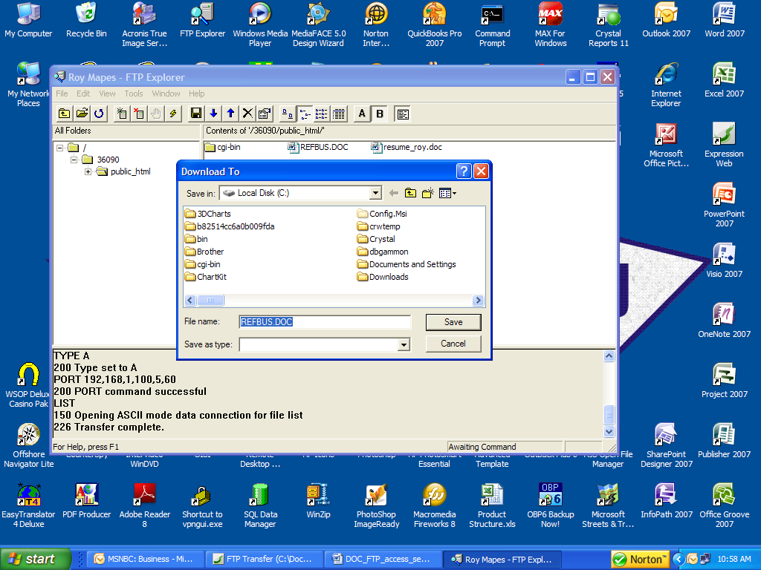

To Upload a file
- To upload a file select “Upload”

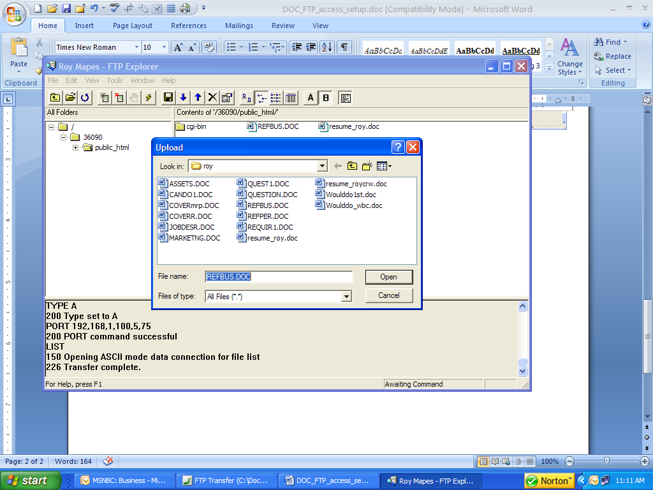

- System will open the “Upload” window.
Navigate to the desired directory holding
the file.

- Click the file name. The system will automatically
upload the file to the FTP sub-directory. You should
see the new file name appear.

- Close the FTP program.

