
111 Snead Dr. • N. Fort Myers, FL 33903
(727) 642-4677
rmapes@mfgsysgroup.com
www.mfgsysgroup.com

Procedure for accessing MSG’s FTP sub-directory

- Open Windows Explorer.
- Copy and paste the following into the address field: ftp://ftp.mfgsysgroup.com/www and enter return.

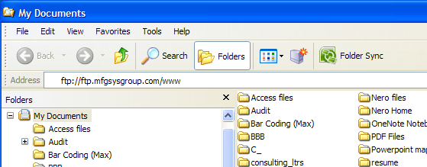

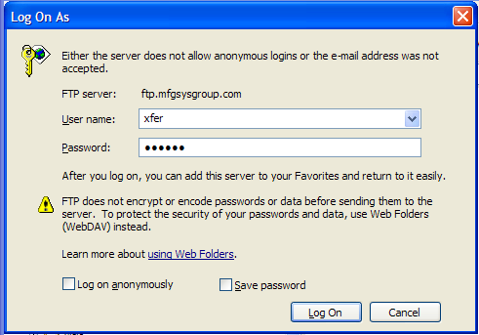
- System will open the following window.
- The user name field should already contain: xfer

- Call 727 642-4677 for the password:

- Click “Log On”

- System will open the following window
- Use normal Explorer copy/paste functions.
