1. PURPOSE

1.1 Process to receive shop orders into stock.

2. SCOPE

2.1 This process will be used to receive all shop orders.

3. RESPONSIBILITIES

3.1 Inventory Control will receive all shop orders.
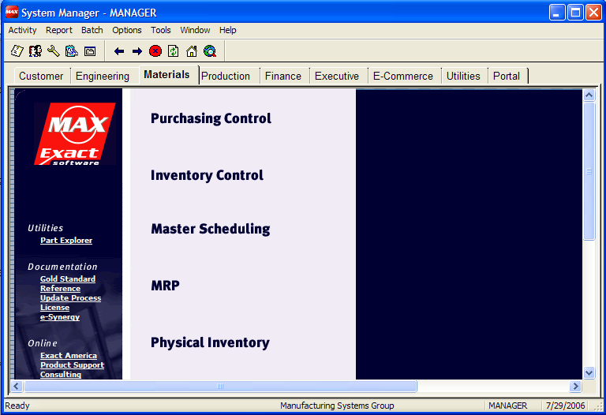
4. PROCEDURE

  - Select “Material” tab.

  - Select “Inventory Control” option

  - Select “Activity” then “Transactions”
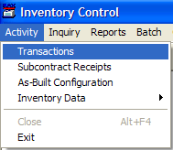

Select “Receipt” tab

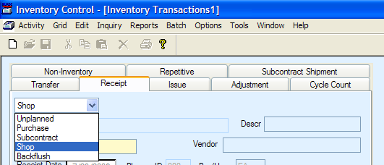
  - Select “Shop” from the
drop down menu

  - Enter shop order number
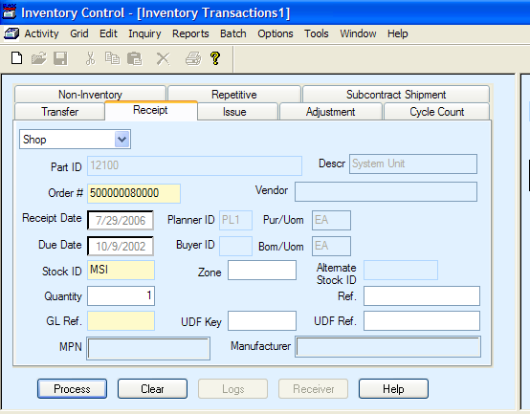
to receive

4.6 Verify Stock ID

  - In the “Quantity” field enter the
number of parts to receive

4.7 Click “Process”

If the part is under lot control the following screen will automatically display.

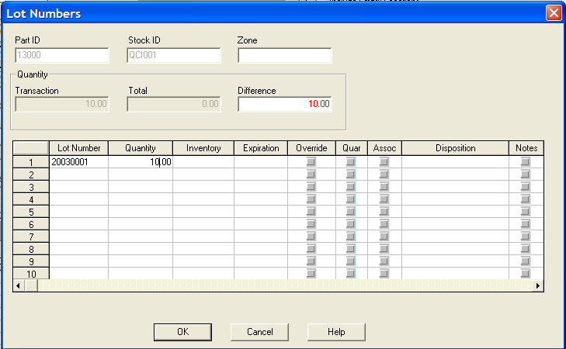
  - Enter the lot number

  - Enter the quantity for this lot

  - Click “OK” to receive the items

  - If there are open shop orders
waiting for these parts the system
will indicate “Requirements Exist”
If the part is under serial number control the following window will automatically appear.
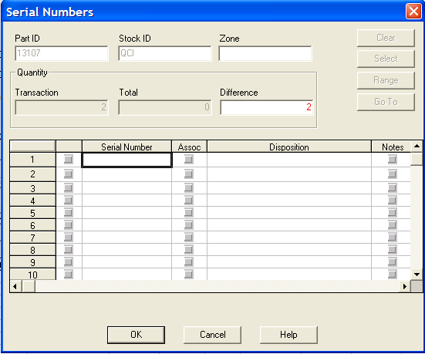
  - The “Difference” field contains the number of items being received.

  - If a few items are being received simply enter the serial numbers in the
Serial Number field.

  - Click “On” the red check mark next to the serial
number. Notice that the “Difference” field will
decrement for each serial number checked. Proceed
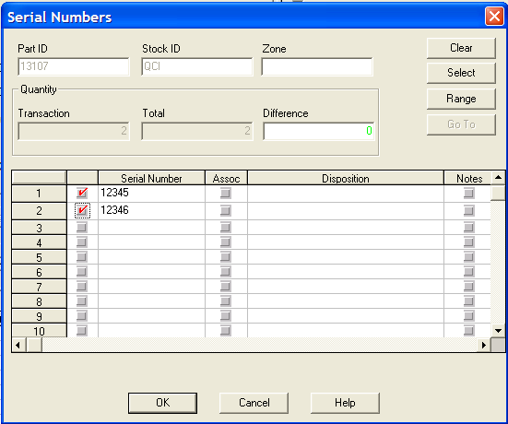
until the difference counter is zero.

  - Click “OK” to process the transaction.

If a large number of serial numbers are being assigned use the following process to select a range of numbers.
  - Click in the left row to highlight the entire row
  - Click “Range” to display the Serial Range window

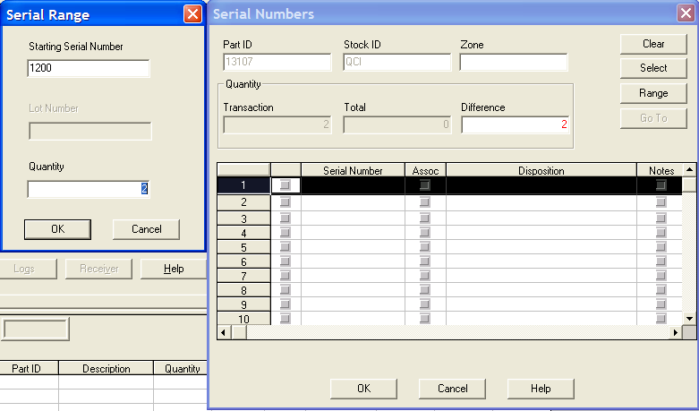
  - Enter the starting serial number

4.19 Enter the number of serial numbers
to generate.

  - Click “OK” to process.

The system will automatically fill in the serial numbers

  - Click “On” the red check mark next to the serial
number. Notice that the “Difference” field will
decrement for each serial number checked. Proceed
until the difference counter is zero.

  - Click “OK” to process the transaction.

