

111 Snead Dr. • N. Fort Myers, FL 33903
(727) 642-4677
rmapes@mfgsysgroup.com
www.mfgsysgroup.com

MRP Project Chart

We always use Microsoft Project to generate a Gantt (bar) chart that includes the following:
- Defining the departments/functions involved (Major heading)
    - Start of project
    - Basic system
    - Inventory Control
    - Physical inventory
    - Shop Floor Control
    - Production Scheduling
    - MRP
    - Purchasing Control
    - Refinement and consolidation (time to review status)
    - Sales Order Entry
    - Final system audit
    - Full system operational
    - Management reporting
    - Document the system
    - Final system review
- Outline the tasks required in all departments
- Document who is going to do the work
- Establish a time line and prerequisites
- Weekly progress meetings
- Monthly review with senior management
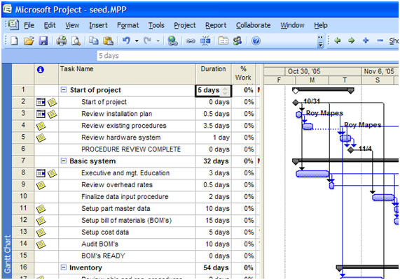

To review the MRP project chart please contact us at:
Phone: 727 642-4677
E-mail: MRP_project_chart@mfgsysgroup.com

Manufacturing Systems Group, LLC - Results you can depend on.

