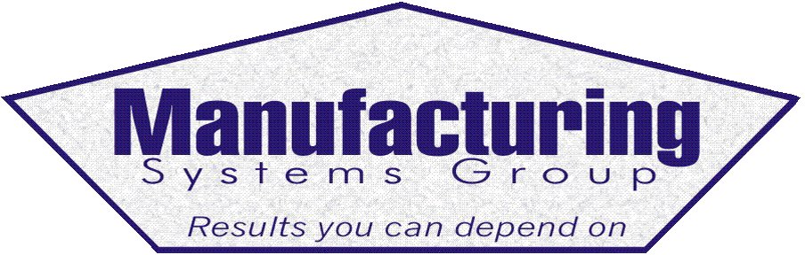

111 Snead Dr. • N. Fort Myers, FL 33903
(727) 642-4677
rmapes@mfgsysgroup.com
www.mfgsysgroup.com

7/28/2026
Dear MAX user:

We have updated our web site and would be pleased if you could browse around in: www.mfgsysgroup.com. Our capabilities include:
- Inventory Control and Inventory Reduction. We have training and processes in place to provide effective Inventory Control as well as Inventory Reduction. With the current economic state inventory reduction coupled with customer satisfaction is more important than ever!
- Offshore Purchasing. We have the expertise to assist in implementation of Offshore Purchasing at your facility. This venture requires selection of Offshore suppliers, quality standards, Freight Forwarders, Inventory readiness to receive and handle container quantities, market forecast for offshore parts, purchasing offshore reports in addition to container tracking and receiving. Training for this venture is a companywide requirement.
- ISO caliber Procedures, Work Instructions and Forms are complete for MFW 4.0 and the new MFW 5.0. These procedures, forms and work instructions, with color screen shots, are designed to provide a base line for your documentation requirements. There are over 460 pages of documentation with examples on our web site for your review!
- MRP Education and Training at your facility. We have the following available today:

- BOM/Engineering
- Inventory Control
- Inventory Reduction
- MRP and Master Scheduling
- Sub Contract processing
- Configurator
- Routings
- Sales Order Entry
- Shipping
- Lot Control & Serial #
- Alert Manager
- Physical Inventory
- Shop Floor Control
- Executive level review
- BOM construction detail
- Repetitive Manufacturing
- Crystal Reports
- Capacity Planning
- Purge and Archive Manager
- Purchasing
- Accounting

- MRP implementation assistance for your MRP system. In general, MRP systems are usually far ahead of the education and training of the people who are assigned to install and use them. In fact, there can be so many problems with the installation that people even question if the tool would work for the average company. We have over 40 years hands-on experience (25 years experience with the MAX system) to assist you in taking your MRP system to the next level. This can include using MAX to drive requirements, inventory reduction, production improvement and data accuracy.
- Crystal Reports. We have over 225 off-the-shelf reports available to efficiently run your business. These reports are for MFW 4.0 and the new SQL database for MFW 5.0
- 2-day MRP Audit. This service continues to be a huge success, as it provides the “State-of-the-union” regarding your MAX system. On the afternoon of the 2nd day, we sit down with you to evaluate our findings and review our written recommendation. All audits are performed by senior level manufacturing personnel with extensive MRP systems experience.

- Vendor Managed Inventory (VMI). Vendor Managed Inventory (VMI) or Real Time inventory is the process of having your vendors (suppliers) keep inventory ready to ship as needed in response to customer or Master Schedule demand. We use fields in your existing database to hold the VMI parameters then launch daily VMI Crystal Reports to signal your suppliers to ship needed material. This concept can eliminate numerous PO’s and simplifies the monthly accounting process. No additional software is required!

Roy Mapes,
President
Manufacturing Systems Group - Results you can depend on

