1. PURPOSE

1.1 To approve MRP manufacturing planned orders (400,000 series). This process automatically converts planned orders to shop orders (500,000 series).

2. SCOPE

2.1 This process will be used to process all manufacturing planned orders in the system.

3. RESPONSIBILITIES

3.1 Production Control is responsible for shop order generation or modification.
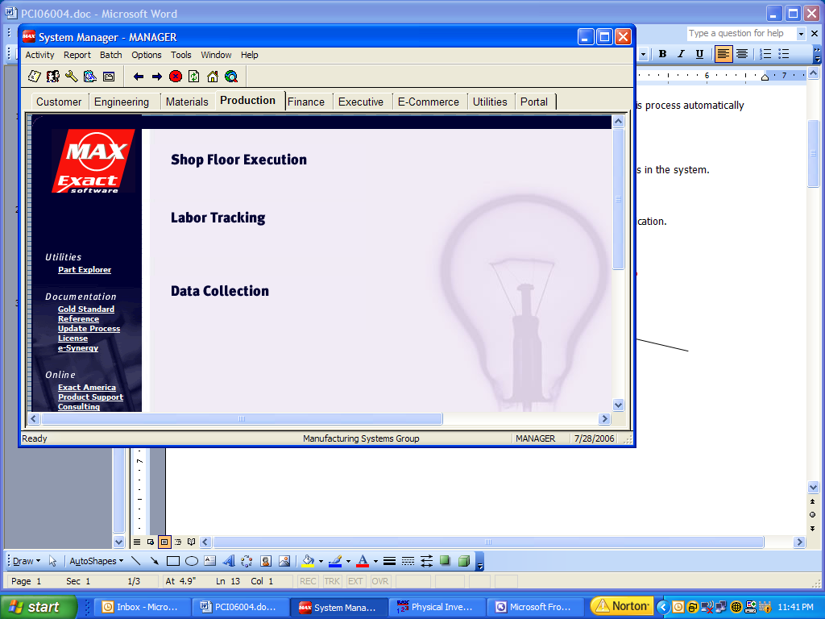
4. PROCEDURE

  - Enter Max for Windows
  - Select “Production” tab.
  - Select “Shop Floor Execution” option

  - Select “Activity” then
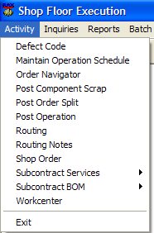
“Order Navigator” from the drop down window

  - In the “Range” box select
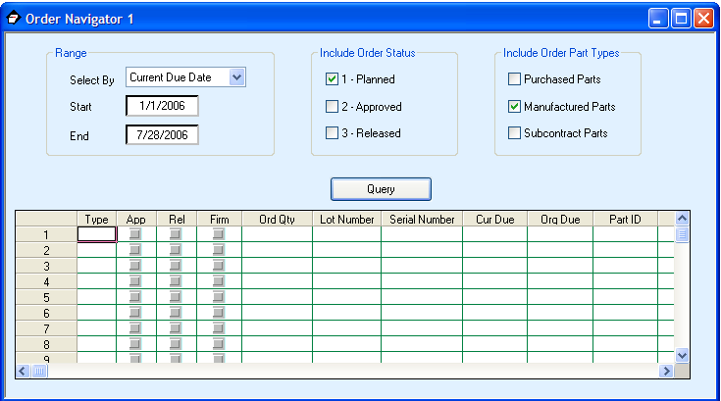
by Current Due date

  - Use the default start date

  - Double click the “End Date”
and select today’s date plus 10 days

  - In the “Include Order Status”
box select “Planned” only

  - In the “Include Order Part Type”
select “Manufactured” only

  - Depress “Query” button to display planned orders

  - Click on 1st order to be approved (Click on order number)
  - Click on Navigator then Release Order
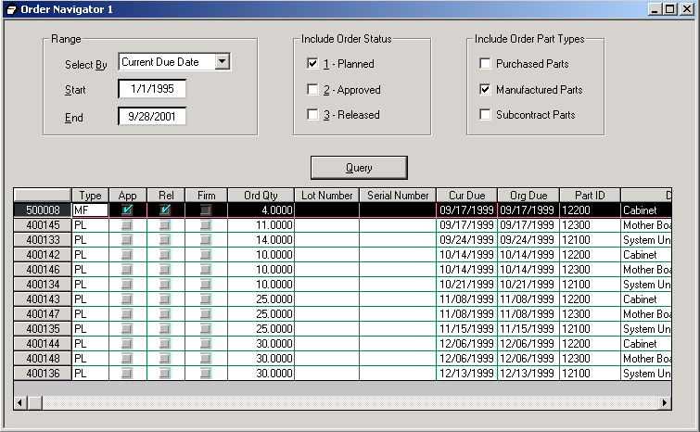
from the drop down window.
Order will change from 400,000
series to 500,000 series.

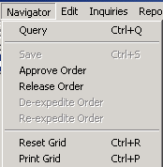

  - Write down the 1st 500,000 series number for later shop order printing.
  - Convert the rest of the 400,000 series planned orders
Note: Click and drag to select a series of 400,000 numbers for conversion.
  - Write down the last 500,000 series number for later shop order printing
  - Print shop orders using work instructions (PCI06007)

