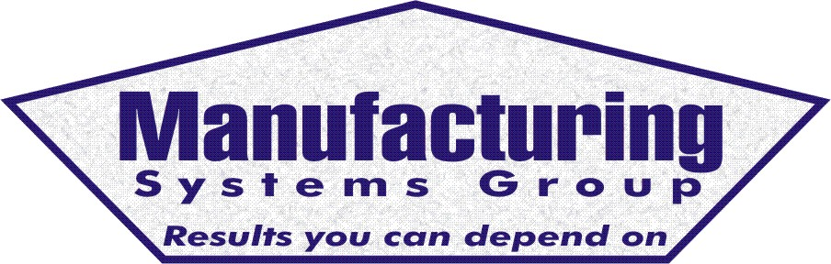
111 Snead Dr. • N. Fort Myers, FL 33903
(727) 642-4677
rmapes@mfgsysgroup.com
www.mfgsysgroup.com

MRP Education and Training
MRP education and training come in several forms. They include:
Education
- MRP system overview for senior management
- Detailed education and training for your MRP coordinator (the teacher)
- MRP philosophy for the mid managers
- Basic understanding of MRP system for the end user
Training
- Project training for overall implementation
- Department specific fundamental training (i.e. Purchasing, Receiving, etc)
- User or operator training for detailed MRP operations (MRP explosion process)
- Performance Monitoring (Setting goals and monitoring results - i.e. Inventory level and turns, stock record accuracy, on-time delivery, BOM's)
- Reports and what is available
- Database overview
In general, MRP systems are usually far ahead of the education and training of the people who are assigned to install and use them. In fact, there can be so many problems with the installation that people even question if the tool would work for the average company.
We recommend a Phase 1 audit of the requirements to generate an MRP "state of the union" and establish a baseline for this worthwhile project.
We have the following off-the-shelf training programs in 4.0 format ready for presentation:

- Engineering
- Inventory Control
- Reducing your Inventory
- Sub-Contract module
- MRP and MS modules
- Purchasing
- Sales Order Entry
- Lot & Serial # Tracking
- Shop Floor Control
- Capacity Planning
- Warranty Tracking
- Purge and Archive Manager
- Shipping
- Executive level overview
- BOM construction detail
- Vendor Managed Inventory (VMI)
- Crystal Reports
- GL Account number setup
- Routing
- Repetitive Manufacturing
- Configurator module
- Physical inventory process
- Alert Manager

All training is performed at your facility using seasoned MRP instructors with many years of actual MRP experience. All training is quoted on a per item basis.
To start the education and training process please contact us at:
Phone: 727 642-4677
E-mail: rmapes@mfgsysgroup.com
Manufacturing Systems Group, LLC - Results you can depend on.

