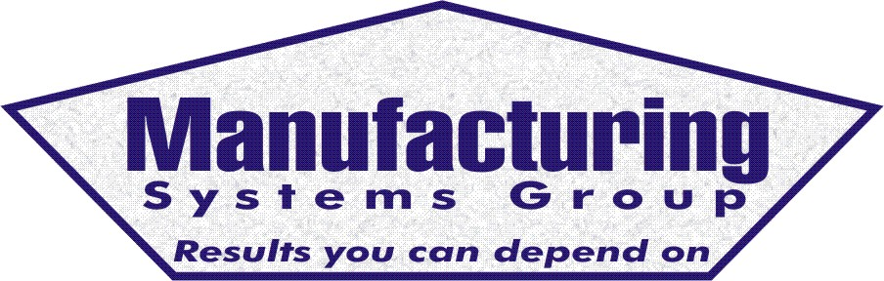

111 Snead Dr. • N. Fort Myers, FL 33903
(727) 642-4677
rmapes@mfgsysgroup.com
www.mfgsysgroup.com

ISO Caliber Documentation
With the move to Windows application with on-line documentation this function is moving toward job or procedure specific documentation to support ISO or QS requirements.
Once a company has made the investment in the MRP software, the proper operation of the system requires a consistent application of data transactions. It is impetrative the details of one's job are documented so turnover, vacations and other times of absence can be handled with a minimum of disruption. This is not a quality issue; these procedures and work instructions are guidelines to build your product the same way day after day!
All documentation is in Word 2000 format and is broken down into three categories:
- Procedures
- Work Instructions
- Forms
Procedures contain the basic process, or paper trail, for performing a function. I.e. what is the procedure for receiving purchased material?
Work Instructions hold the exact process for performing the function. I.e., Open this screen, navigate to this menu and input the data.
Forms are documents that keep track of exceptions to the normal daily operation of the business. (Missed customer shipment log, premium freight log, recovery and corrective action, etc.)
Manufacturing Systems Group has Procedures, Work Instructions and Forms completed for the following areas:
Department | # Pages
Purchasing | 52
Inventory Control | 80
Production Control | 91
Sales Order Entry (Customer Service) | 32
Engineering | 59
Labor Tracking | 19
Information Systems | 78
Alert Manager | 3
Accounting | 26
Sales/Marketing | 1
ISO Administration | 18
Total: | 459
For more information on ISO caliber documentation please contact us at:
Phone: 727 642-4677
E-mail: rmapes@mfgsysgroup.com
Manufacturing Systems Group, LLC - Results you can depend on.

