“
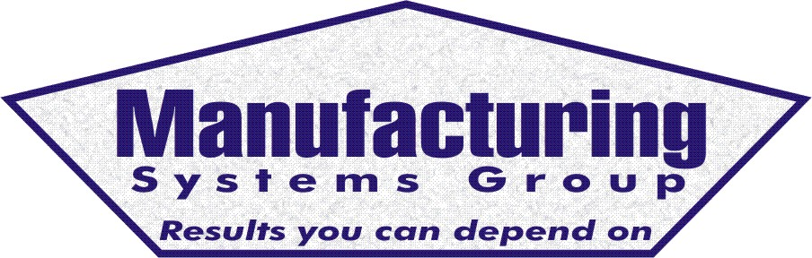

111 Snead Dr. • N. Fort Myers, FL 33903
(727) 642-4677
rmapes@mfgsysgroup.com
www.mfgsysgroup.com

Offshore Purchasing Audit
7/28/26

Offshore Purchasing can provide a company the economic benefits of purchasing selected items from offshore manufacturing suppliers. This is not a simple task and several factors must be considered before undertaking this venture.

- Selection of potential products and supplier.
- Quality assurance process from offshore supplier.
- Training in the offshore purchasing process. This is a companywide education requirement.
- Lot size and container loading procedure.
- Offshore part forecasting and report process.
- Lead times and scheduling reports.
- Freight forwarder and customs process.
- Type of bond selection.
- Inventory and safety stock levels to support 3 months’ delivery schedules.
- Inventory impact for receiving container quantities.
- Container tracking process.
- Container "Receiving" procedure.
- Documentation and procedures.
We are prepared to assist you in getting this Offshore Purchasing effort in place at your facility!
To start the process, we will send two highly skilled, offshore experienced, manufacturing consultants to your facility for two days to audit the Offshore Purchasing potential at your facility. This audit will include purchasing, minimum order quantities, inventory storage, “Pull-From” inventory requirements, accounting and safety stock cash requirements, marketing long range forecasting, report requirements and other procedures along with target parts for offshore consideration. Not all issues will be discovered from this audit, however the audit will identify major issues for offshore purchasing.

On the afternoon of the 2nd day we sit down and review our findings and discuss our written recommendations.
To inquire about Offshore Purchasing please contact us at:
Name: Roy Mapes
Phone: 727 642-4677
E-mail: rmapes@mfgsysgroup.com

Manufacturing Systems Group – Results you can depend on

