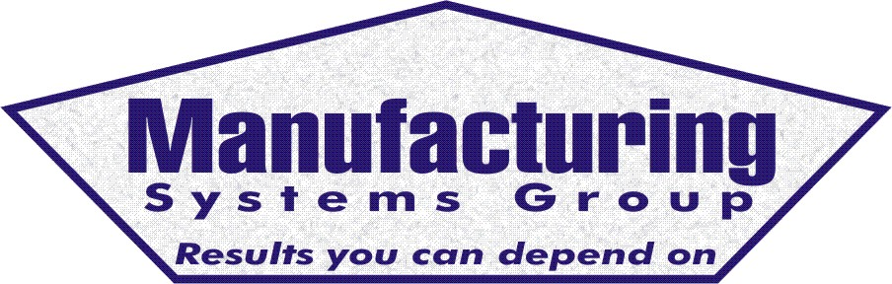

111 Snead Dr. • N. Fort Myers, FL 33903
(727) 642-4677
rmapes@mfgsysgroup.com
www.mfgsysgroup.com

On-Site Assistance
Manufacturing Systems Group is well versed in assisting users to get their MRP system up and running. We have implemented many MRP systems in the past and continue to assist new and existing users with difficult problems today. An example may be:
- Overview of MRP philosophy for senior management
- Detailed MRP education and training for the users
- Training for your "MRP coordinator" person
- Assistance in setting up project plan for implementation
- Provide guidance for project management
- Physical inventory assistance
- Inventory review and evaluation
- Set up Vendor Managed Inventory with your vendors.
- Procedure definition and generation
- Recommendations for system automation
- Material flow

A consultant's "product" is his or her expertise. Whether clients choose a large or small firm, they are ultimately buying the expertise of individuals, so clients are advised to inquire about the experience of the consultants who will actually work on their project, not just the backgrounds of the principal consultants.
We have over 40 years experience in the manufacturing MRP arena coupled with 21 years experience with Exact/Kewill’s DOS MAX and MAX for Windows MRP systems.
On-site assistance will be quoted on a per project or visit basis.
For more information on On-Site Assistance please contact us at:
Phone: 727 642-4677
E-mail: rmapes@mfgsysgroup.com

Manufacturing Systems Group, LLC - Results you can depend on.

