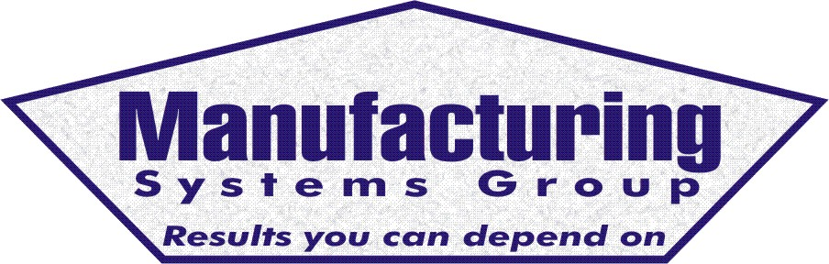

111 Snead Dr. • N. Fort Myers, FL 33903
(727) 642-4677
rmapes@mfgsysgroup.com
www.mfgsysgroup.com

Senior level MRP implementation overview
Basics of MRP implementation – 1-2 hours

- Path to success ( what is required)
  - Audit assessment
- Vision statement (What do we want to accomplish)
- Project organization

- Steering committee
- Strong MRP coordinator
- Project team of key players
- Outside consulting

- Performance goals
- Initial education
- Data management
- Accuracy and accountability
- Process improvement
- Performance measurements
- Inventory accuracy
- On time delivery
- Bill of material
- Planning and control
- Order entry through invoicing
- Mater flow from receiving through shipping
- Bill of material
- Audit assessment
- On going education requirements
- Prerequisite of successful implementation

- Top management involvement
- Company wide education
- Well defined goals
- Implementation schedule

- Business and marketing plan
- Production and shop floor load plan
- Master Production Scheduling, if used
- Capacity planning
- Inventory A-B-C analysis
- MRP system
- Pilot project
- Project planning and management
- Policy and procedure development
  - Procedures
  - Work instructions
- Monthly management reports
- Where others have failed
- Summary and Q&A

Manufacturing Systems Group – Results you can depend on

