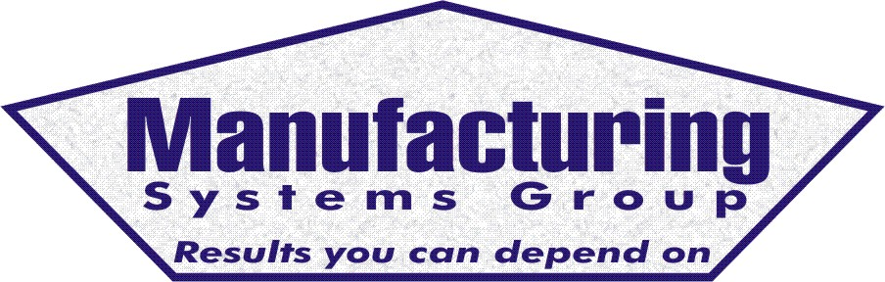

111 Snead Dr. • N. Fort Myers, FL 33903
(727) 642-4677
rmapes@mfgsysgroup.com
www.mfgsysgroup.com

Vendor Managed Inventory (VMI)
Vendor Managed Inventory (VMI) or Real Time inventory is the process of having your vendors (suppliers) keep inventory ready to ship as needed in response to customer or Master Schedule demand. The Internet can be used to institute electronic real-time supply orders on daily or weekly bases. The net result is the reduction of paperwork (PO's) in the system, lower on-hand inventory levels and timely receipts of raw material in response to changing demand patterns. This is done using your existing MAX/MFW or other MRP system without purchasing additional modules.
Implementation of VMI is a learning process for you and your suppliers. Training and a good understanding of the VMI process must exist prior to starting this project. Agreements and procedures must be in place for:
- Over/Obsolete stock and what to do if it exists
- Large variations in customer orders from what is expected
- Promotions that can change forecasted orders
- Testing of the communication systems
- Training of all employees involved in the process so they fully understand and accept this new way of doing business.
- An understanding of "who owns the inventory" in the suppliers stock?
As with all our projects we recommend a phased approach to this project.
- Phase 1 would be a 2-day system audit to establish VMI potential and review initial requirements.
- Phase 2 is the development of a pilot project with 1 or 2 suppliers to establish procedures, training requirements and "iron out the kinks". This also includes the accounting function and how the receipts of goods are processed.
- Phase 3 establishes performance indicators for monitoring the VMI process. Inventory levels, turns and on-time delivery performance are an example.
- Phase 4 is the deployment of additional suppliers into the VMI process.
For more information on Vendor Managed Inventory please contact us at:
Phone: 727 642-4677
E-mail: rmapes@mfgsysgroup.com

Manufacturing Systems Group, LLC - Results you can depend on.

